**Apartment for Rent**

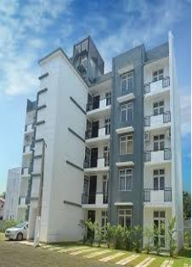**Location:**

Sukhumvit 52